<http://shatterline.com/blog/2013/09/12/not-so-naive-classification-with-the-naive-bayes-classifier/>

In naive Bayes classification, In training phase, we need calculate following  
1) All the likely hood probabilities.  
2) Probability of each class.  
Time complexity for training phase:   
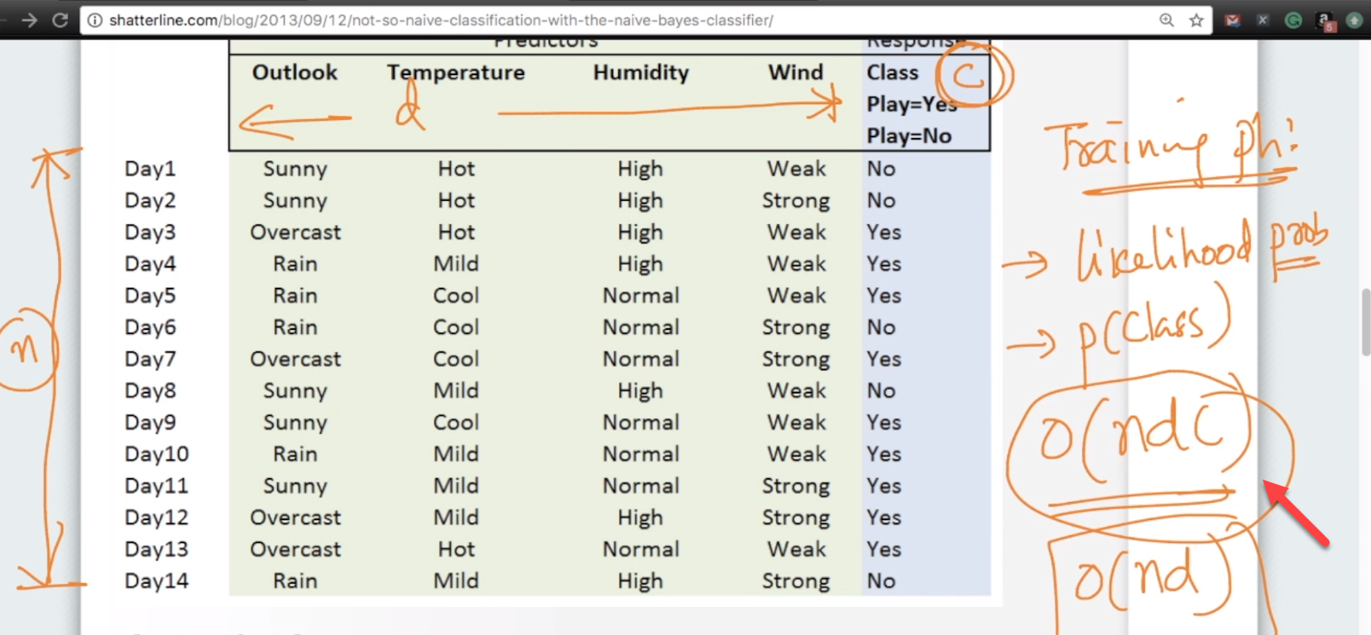

Here, basically we calculating probability of each word in corpus per it’s class label and total probability of each class lable i.e., Yes/No

Once we done above, we can proceed with testing phase.   
Space complexity for training phase:  
If you have d-features and c classes it is d\*c it is o(d\*c)  
As compare to Knn, naive is much better in terms of space complexity at run time as there is less space complexity